TP-Link Systems Inc.
Router&FW develop guide
Module: | Router&FW develop guide
Version: | V0.1
Completion Date: | 14Mar2025
Author: | Eddie Xie
Reviewer:
Approver:
Document Status: | ■Draft □ Official release □ Under revision

Version History
Version/Status | Owner | Duration | Notes
V0.1/Draft | Eddie.xie | 14Mar2025
catalogs
1. SMB Router software platform introduce 1
1.1. Overview 1
1.2. Code repo introduces 1
1.3. Platform directory structure 1
1.3.1. Root directory introduce 1
1.3.2. Introduction to common directory 3
2. Download and compile the project 4
2.1. Download codes 4
2.2. Compilation 6
2.3. UPDATE/program device 7
3. Development 13
3.1. Add new module package 13
3.1.1. Writing module code 14
3.1.2. Join compilation frameworks 14
3.2. Add new products 16
3.2.3. Firmware compilation adaptation 16
3.2.4. Uboot compilation and adaptation 25
4. Debug 29
4.1. Console/SSH log in 29
4.2. Enable all ports while using an unsigned device 30

SMB Router software platform introduce

Overview
SMB Router platform is a Linux development platform which is independently modified by our company on the basis of OpenWrt platform. This platform not only retains the advantages of OpenWrt platform, such as high modularity, simple configuration and easy compilation, but also is compatible with the SDKs of different chip makers, which improves the stability, scalability and easy maintenance compared with the old platform.
This document mainly introduces the organizational structure and compilation framework of the new SMB Router software platform, focusing on the Makefile that controls the compilation process and its configuration file storage path and development rules, and then explains the methods of download,compilation and programming.

Code repo introduces
Below is a list of git code paths for all current SMB Router software platforms and a description of their uses, including paths for sdk and device codes.
Repo name | Indroduce | Link
SMB/omada_gateway | Main repo,including most of the device codes. | SMB/omada_gateway · Gerrit Code Review
SMB/omada_gateway/sdk_marvell | Marvell SDK | SMB/omada_gateway · Gerrit Code Review
SMB/omada_gateway/sdk_mtk | MTK SDK | SMB/omada_gateway/sdk_mtk · Gerrit Code Review
SMB/omada_gateway/sdk_qca | QCA SDK & DSL chip code | SMB/omada_gateway/sdk_qca · Gerrit Code Review
SMB/enterprise_iplatform | New platform repo,some of new product’s compilation have to include this repo. | SMB/enterprise_iplatform · Gerrit Code Review

Platform directory structure
The role of stability testing in quality assurance includes the following:
SMB Router software platform code must be downloaded under Linux system (usually Ubuntu) using the git clone command, in addition, the code must also be compiled under the Linux system. The root directory of the git repo path of the main platform code currently under development is as follows:
SMB/omada_gateway · Gerrit Code Review

Root directory introduce

Since the new software platform of SMB Router is based on OpenWrt, its directory structure almost directly follows the directory structure of OpenWrt. The following first describes the role of each directory under the root directory:
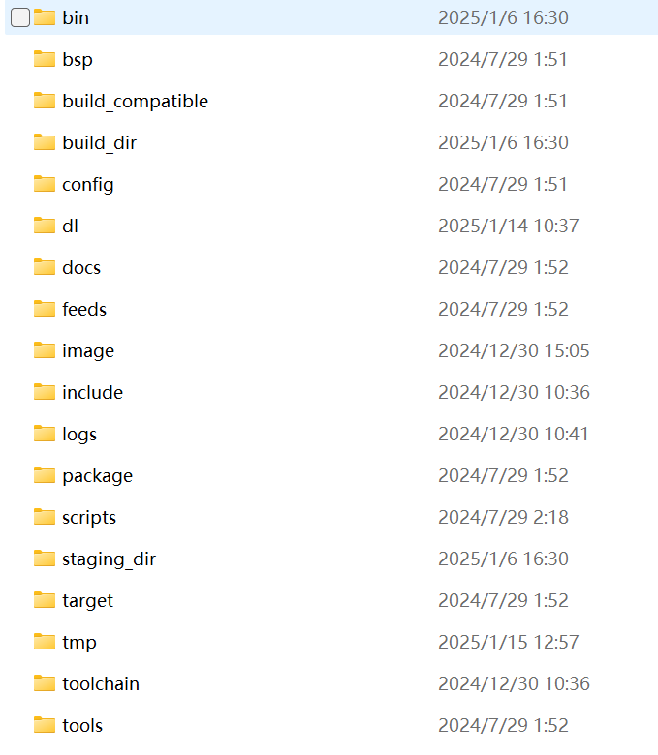
Figure 1-1 root directory
directory name | Function
bin | Automatic generation, including mirror files for this compilation, module ipk files, etc.
bsp | Bsp platform code, work with enterprise_iplatform repo when it’s been enabled.
build_compatible | Compile compatible layer,including codes which needs to do compatible design.
build_dir | Automatically generated, including intermediate compilation products for this compilation.
config | Compile Configuration File.
dl | Download directory for packages needed for compilation.
docs | OpenWrt Platform Documentation
feeds | Module packages for the OpenWrt platform, mainly including the module platform framework Makefiles and patches
image | compiled image files
include | OpenWrt Platform Compilation Control Makefile Files
logs | Automatically generated, including makefile output logs when compiling.
package | Generic module packages, mainly platform Makefiles and patches for modules
scripts | Scripts required for the compilation process
staging_dir | Auto-generated, current compilation environment, bin file with toolchain
target | Directory for chip vendor SDKs, kernel patches, and kernel compilation methods.
tmp | Automatically generated,including temporary file
toolchain | Compilation toolchain
tools | Other compilation tools.
tplink | Including private developed module, bootloader and products’ configuration file of our company.

Introduction to common directory
There are also a number of subdirectories that you may need to come into contact with frequently in your daily development, which are listed in the table below：
Secondary Catalog | Third and above catalog | Function
bin | [target]-[model] | Such as ipq806x-tl-er6020_un_v2, named after product names, stores the compiled image files and module ipk files.
build_dir | target-[arch]-[toolchain]-[model]/[package] | Such as target-arm_cortex-a7_uClibc-1.0.14_eabi-tl-er6020_un_v2 /lua-5.1.5，the compilation directory named after the module, where the module source code will be copied before compilation. After modifying the code, you need to delete this directory before making.
build_dir | target-[arch]-[toolchain]-[model]/linux-[target]/[package] | Such as target-arm_cortex-a7_uClibc-1.0.14_eabi-tl-er6020_un_v2/linux-ipq806x/ipset-6.29, the compilation directory named after the kernel module, where the module source code will be copied before compilation. After modifying the code, you need to delete this directory before making.
build_dir | target-[arch]-[toolchain]-[model]/linux-[target]/linux-[version] | Such as target-arm_cortex-a7_uClibc-1.0.14_eabi-tl-er6020_un_v2 /linux-ipq806x/linux-3.14.77，the compilation directory for the Linux kernel. After adding patches, you need to delete this directory before making.
build_dir | target-[arch]-[toolchain]-[model]/root-[target] | Such as target-arm_cortex-a7_uClibc-1.0.14_eabi-tl-er6020_un_v2 /root-ipq806x，the file system directory, where each module copies its own files to this directory through make install, compiles them, and packages them together.
image | [model] | Such as tl-er6020_un_v2, backup of all compiled image files。
package | base-files | Basic file system framework, mainly including some common scripts.
package | tplink/[package] | Such as tplink/access_ctl, including makefiles of modules。
package | network/config/firewall | Private firewall module and source code.
package | qca/shortcut_fe | Sfe module source code。
staging_dir | toolchain-[arch]-[toolchain] | Such as toolchain-arm_cortex-a7_gcc-4.8-linaro-ipq_uClibc-1.0.14_eabi，including the binary file of toolchain, usually help for debug.
target | linux/generic/patches-[version] | Including generic patches unrelated to chips. Generally, modifications to the kernel are completed in patches file and stored in this path
target | linux/[target]/patches-[version] | Such as linux/ipq806x/patches-3.14.77, including patches related to chips.
tplink | configs/[model] | Such as configs/tl-er6020_un_v2, including product configuration, partition information and other files.
tplink | opensource/[package] | Such as opensource/netifd，including opensource codes.
tplink | package/kernel/[package] | Including independently developed kernel modules.
tplink | package/network/[package] | Including independently developed modules about network.
tplink | package/qca/[package] | QCA private codes, mainly about NSS。
tplink | package/tp-luci/luasrc | Including lua scripts for luci, luci is equivalent to the parser of a web server
tplink | package/usr_package/[package] | Other independently developed modules
tplink | u-boot | Including bootloader for all products.
tplink | webpages | Web ui source.

Download and compile the project

Download codes
You can use the virtual machine provided to directly start download and compile:
\\file.tp-link.com\Enterprise Business\Enterprise R&D\Public\Eddie\NEW VM
Our codes are all stored and organized by git. The main project is omada_gateway, most products only need this to complete the compilation
Follow these steps to download
- Configure git
Input commands, replace them with your own username and email address.
git config --global user.name “username”
git config --global user.email “email”
- Generate your ssh key
Input commands, replace them with your own email address.
ssh-keygen -t rsa -C “email”
And then just press enter until command is completed.
- Add your key to gerrit
First copy your public key which generated in step 2:
cat /home/xxx/.ssh/id_rsa.pub
（replace xxx with your username）
Log in gerrit with your tplink email and password.
Gerrit Code Review - Sign In
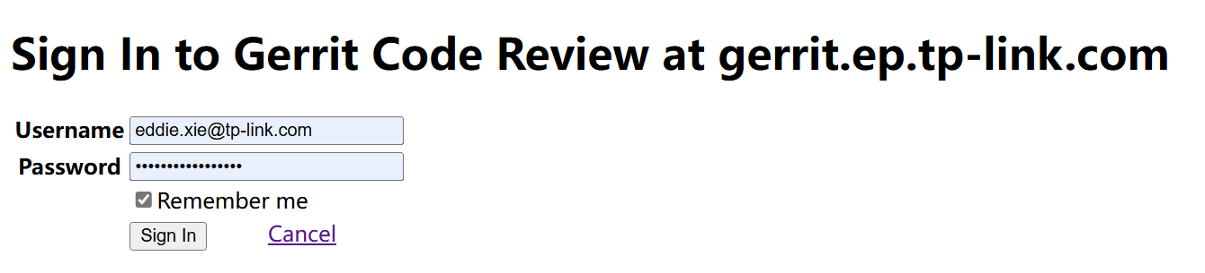
After log in, press the Settings which locate in the top right side of the page.
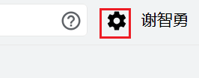
Press SSH KEY button.
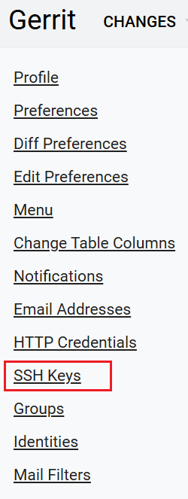
Paste your public key in the New SSH key form. And then press ADD NEW SSH KEY button, usually you will receive an email immediately after successfully.
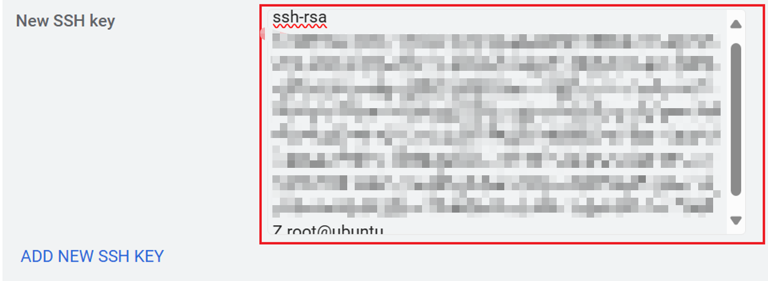
- Download codes
Click the following link or find your target repo on the gerrit website.
SMB/omada_gateway · Gerrit Code Review
Copy the git clone command and run command in your Linux command line.
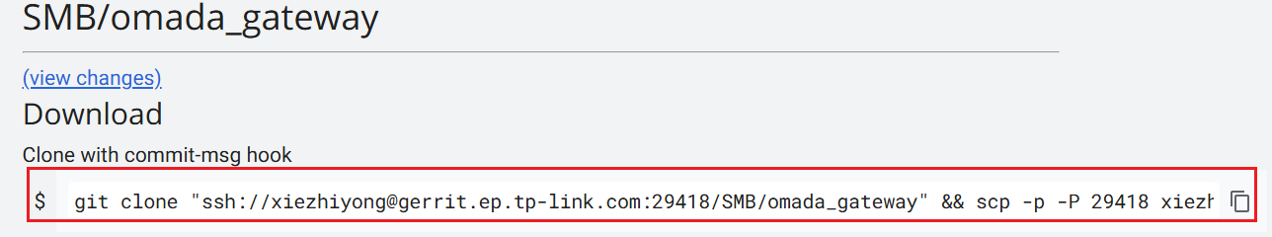

Compilation
When you try to compile ER7412-M2 firmware, please use branch tps_devlop instead of master, because master is not a stable branch for compile 7412-M2 now.
git checkout tps_devlop
Our webpages module, which includes web ui codes, is now defined as a submodule, so it it necessary to pull the submodule before compile, use these commands:
git submodule init
git submodule update
And then cd to the root directory of omada_gateway, input following command:
./build.sh xxxx
The xxxx is the product name, which can be seen in the build.sh script:
case "$PRODUCT" in
"er7206v2" | "er706wv1" | "er707-m2v1" | "er706w-4gv1" | "er7412-m2v1")
linux="5.4"
gcc="8.4.0"
make_mt798x "$linux" "$gcc" "$PRODUCT" "$COMPILE_CPU_NUM"
For example, if you want to compile ER7206v2 image/firmware, just input:
./build.sh er7206v2
After complete, the firmware will be automatically generated in the bin or image folder(which depends on specific devices).
The following command can be used to clear all compiled/temporary files:
make clean
If you need to compile and clear the module package separately, then you need to enter the following command (where XXX is the module name):
1: make package/XXX/compile V=s # compile
2: make package/XXX/install V=s # installation，must do install before build image
3: make package/XXX/clean V=s # clean compiled files
If you need to compile and clear the kernel separately, enter the following commands:
1: make target/linux/compile V=s # compile
2: make target/linux/install V=s # install and package image
3: make target/linux/clean V=s # clean
Note: During the compilation process, the compilation framework will copy the source code to the omada_gateway/build_dir directory before compiling, so if you have any code modification, please delete the folder named after the module in the omada_gateway/build_dir directory first, or execute the make clean command first and then re-execute make's compile command. A quick debugging method is to modify the code directly in the code copy in omada_gateway/build_dir, and then compile it with the latest code changes to improve debugging efficiency.
Some products need enterprise_iplatform repo to complete the compilation, you can check it in the device`s configuration file.
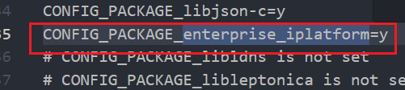
If CONFIG_PACKAGE_enterprise_iplatform is enabled, you need to download it and put it in the same directory as omada_gateway and then start your compilation.
If you are trying to compile ER7412-M2 on tps_develop, please checkout enterprise_iplatform repo to branch tps_develop.
git checkout tps_develop
SMB/enterprise_iplatform · Gerrit Code Review
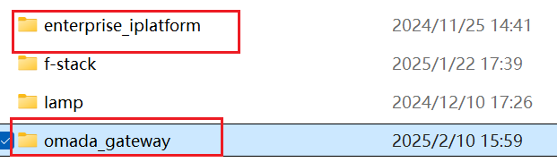

UPDATE/program device
There will be several types of image will be generated after compilation, here is an example of SR606.
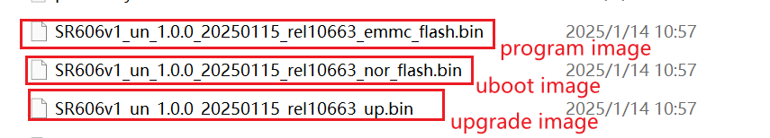
- upgrade image
Most common and important image, which will also be provided to user as upgrade firmware.It must be signed before upgrade device.
Click the following link and sign the XXX_up.bin,make sure you have the access and log in with your TP-LINK account.
固件签名 – 研发签名系统
After downloading the firmware, you can simply upgrade your device on the web pages.
Enter System Tools->Management->Firmware Upgrade,first browse and choose your signed up.bin file and upload, and then click upgrade to upgrade the device.
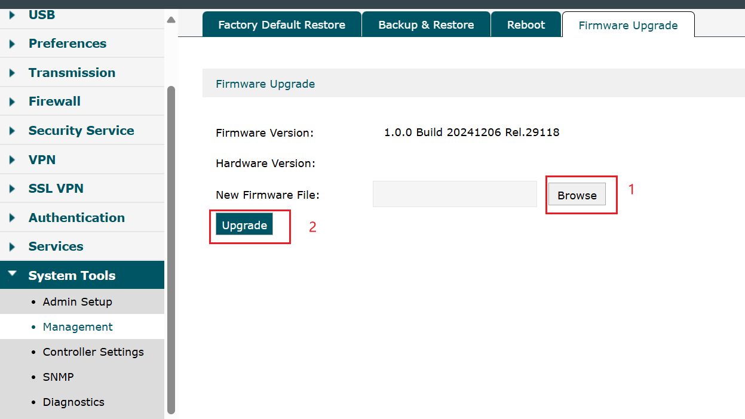
- program image(nandflash)
Basically store all necessary data for a device, including filesystems,configurations,profiles,etc.(only except uboot).Please try to use upgrade image first, because it is dangerous that if you run the wrong command during programming the device may became unavailable.
- uboot image(norflash)
Including uboot of the device, do not upgrade it if there is no change on uboot, incorrect
commands may lead to serious issues such as unavailability of the prototype.
Here to list the program commands of some devices, please confirm the command before using it:
7206v1/8411 nandflash
1.Press enter twice for 7206v1 and press enter for 8411 whiling device initing
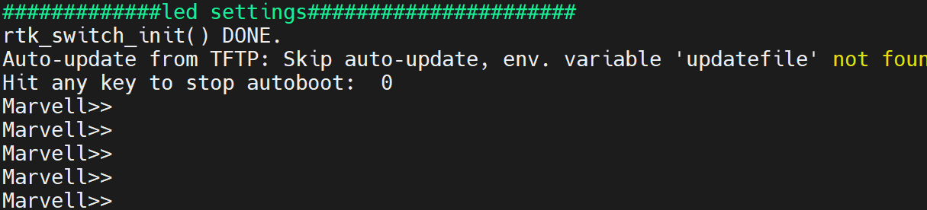
2.Enable the network port: 7206 executes run enphy, 8411 executes switch init
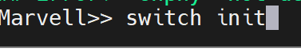
3.Set the IP address (this step can be skipped, the default IP address will be used),the ipaddr means ip of your device ,the serverip means tftp server ip address(usually your pc ip):
setenv ipaddr 192.168.0.10
setenv serverip 192.168.0.146
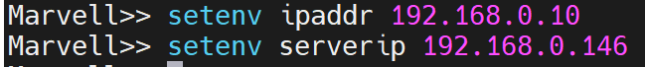
4.tftp ***_nandflash_noecc.bin(use tftpboot for 8411)
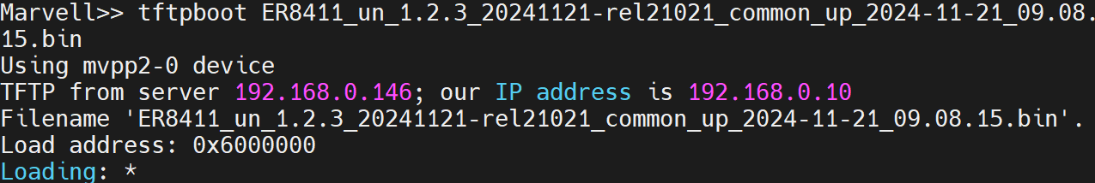
5.nand erase [offset ] $(filesize) Or use the convenient command nand erase.chip to erase the flash
6.nand write $(loadaddr) [offset] $(filesize) program flash
This step requires uboot to support global variables, otherwise $(loadaddr) and $(filesize) need to be entered manually. It is known that 7206 uboot supports it. The offset is usually 0, which can be seen in the serial port output during the burning process.
7.reset
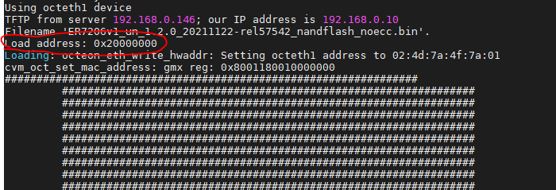
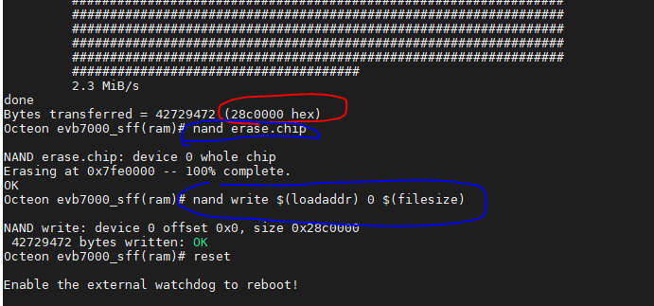
(Red is the programming output, blue is the input instruction, here $(loadaddr) is 0x20000000, offset is 0, $(filesize) is 28c0000, uboot supports global variables)
7206v1/8411 norflash
norflash and nandflash need to correspond to each other. Generally, only nandflash needs to be programed,please check before program norflash. However, if the newly obtained prototype is relatively old and the running norflash is relatively old, it is necessary to update and program norflash
If the flash itself has not been significantly modified, norflash only needs to be burned once. The steps are as follows
1. Press enter twice when starting up 7206v1 and press enter when starting up 8411
2. Open the network port: 7206 executes run enphy and 8411 executes switch init
3. sf probe selects flash. Since there are no more norflash at present, there is no need to select manually after executing this command
4. Set the ip address, which is the same as the corresponding command in nandflash programming. You can also not set it and use the default address
5. sf erase [offset ] $(filesize) erases flash, no convenient command
6. sf write $(loadaddr) [offset] $(filesize) Write flash, the operation is consistent with nandflash
7. reset
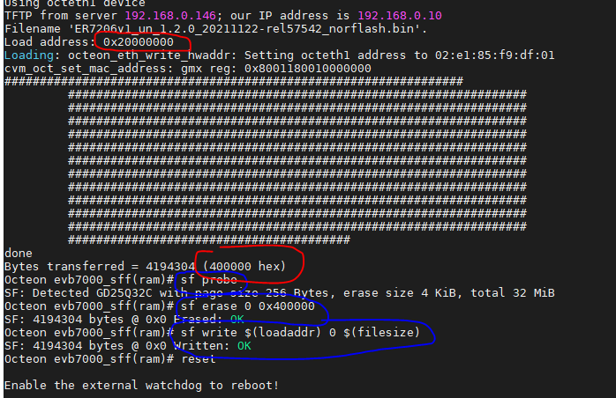
ER605v2
1. Turn on the computer, press the ↓ arrow key in the U-Boot Boot Menu, select 2, and press Enter to enter the upgrade mode.
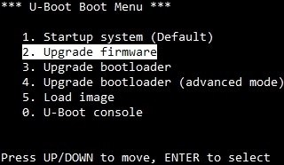
2. Select the tftp mode by default, set the U-Boot IP (device IP) and Server IP (PC IP), ensure that the PC's tftp server points to the Flash image directory of ER605v2, select the noecc type, fill in the file name, and finally press Enter. As shown in the figure below.
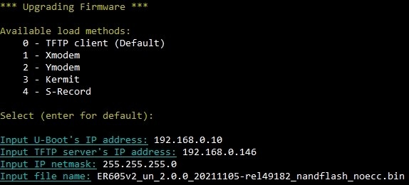
3. If the following error message appears, it may be because the old uboot boot is larger in size and the firmware is not completely erased when writing. You can try the following steps to erase it.
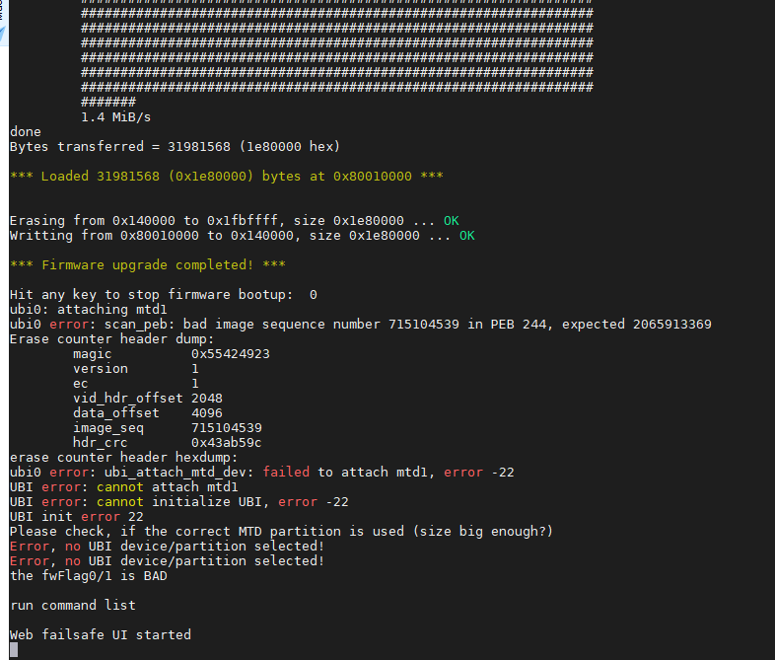
Reboot, press 0 in the U-Boot Boot Menu, enter the U-Boot Console, execute the command nand erase.part firmware to clear the firmware partition, then restart and execute the previous programming steps.
ER7206v2、ER706W、ER707-M2、ER706W-4G：
setenv ipaddr 192.168.0.10
setenv serverip 192.168.0.100
ena
tftpboot ER706Wv1_eu_1.1.2_20240726-rel69942_nandflash_noecc.bin
mtd erase spi-nand0 0x0 0x8000000
mtd write spi-nand0 0x46000000 0x0 0x7680000 (0x7680000 is changed to the actual tftpboot file size)
reset
ER7412-M2:
If you can not login web-ui on ER7412-M2 because of the firmware fault, you can follow these steps to simply upgrade firmware in recovery mode.
- Long press the reset button while 7412-M2’s booting.
- Config your pc’s ip address, and log in to 192.168.0.10 by browser
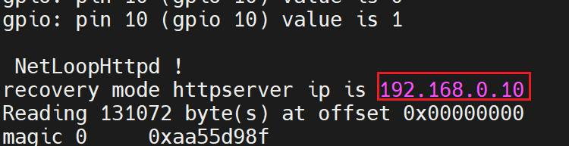
- Click browser and choose your up.bin to upgrade.
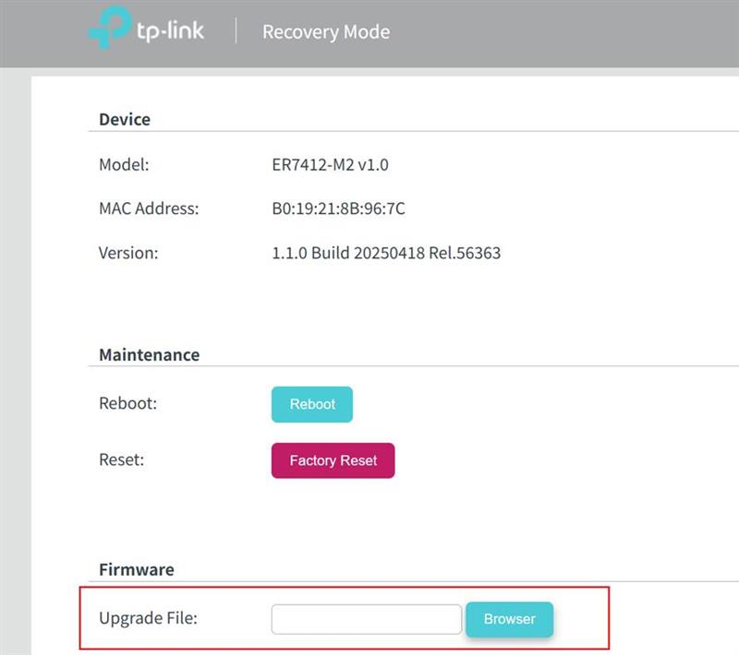

SR606:
setenv ipaddr 192.168.0.10
setenv serverip 192.168.0.100
(norflash)(please confirm before programming)
tftpboot SR606v1_un_1.0.0_20240422_rel35088_nor_flash.bin
sf probe
sf erase 0 0x200000
sf write 0x6000000 0 0x200000
(nandflash)
tftpboot SR606v1_un_1.0.0_20240422_rel35088_emmc_flash.bin
mmc erase 0 0x1000000;mmc write 0x6000000 0 42A00;reset

Development
This chapter will discuss how to do development work on our platform ,including how to add new module or add a new product to our platform.

Add new module package
In the process of development, sometimes you need to add a self-developed private module, at this time must be in accordance with the OpenWrt compilation specification to add the module package to the software platform, add the steps are mainly divided into:
(1) write the module code and Makefile, this Makefile is used for compiling the module.
(2) join the OpenWrt compilation framework, create a module directory, Makefile, configuration and other files, this Makefile is used for compilation control in the compilation framework.

Writing module code
First write the module code as well as the Makefile according to the code specification, the Makefile examples for the upper layer application and kernel module are given below (from omada_gateway/tplink/package/usr_package/xt_dosdrop) respectively:
Upper-level application Makefile:
CFLAGS += -Wall –Werror

libxt_dosdrop.so: libxt_dosdrop.o
$(CC) $(LDFLAGS) -shared -o $@ $^

libxt_dosdrop.o: libxt_dosdrop.c
$(CC) $(CFLAGS) -fPIC -c -o $@ $<

# remove object files and lib when user executes "make clean"
clean:
rm -rf *.o *.so
kernel module Makefile：
obj-m += xt_dosdrop.o
When finished, create a directory with the same name as the module in the omada_gateway/tplink/package/usr_package directory and store the module code in the src directory under that directory, for example omada_gateway/tplink/package/usr_package/ xt_dosdrop/src.
If you also need to copy some files (e.g., configurations, scripts, etc.) to the filesystem, place these files in the following directory omada_gateway/tplink/package/usr_package/xt_dosdrop/files.
The final directory structure might look like the following figure:
omada_gateway/tplink/package/usr_package/xt_dosdrop/
├── files
│ ├── etc
│ │ └── init.d
│ │ └── *
│ └── usr
│ └── sbin
│ └── *
└── src
├── Makefile
├── *.c
└── *.h

Join compilation frameworks
The Makefile for the compilation framework defines the basic information for compiling this module for the OpenWrt platform and adds options for compiling this module in the make menuconfig menu.
First you need to create a directory with the same name as the module in the omada_gatway/package/tplink directory, where the Makefile exists, e.g. omada_gatway/package/tplink/xt_dosdrop/Makefile.
Then create the Makefile for the framework, the Makefile for the framework has the following rules, where PKG_NAME is recommended to be the same as the module directory name:
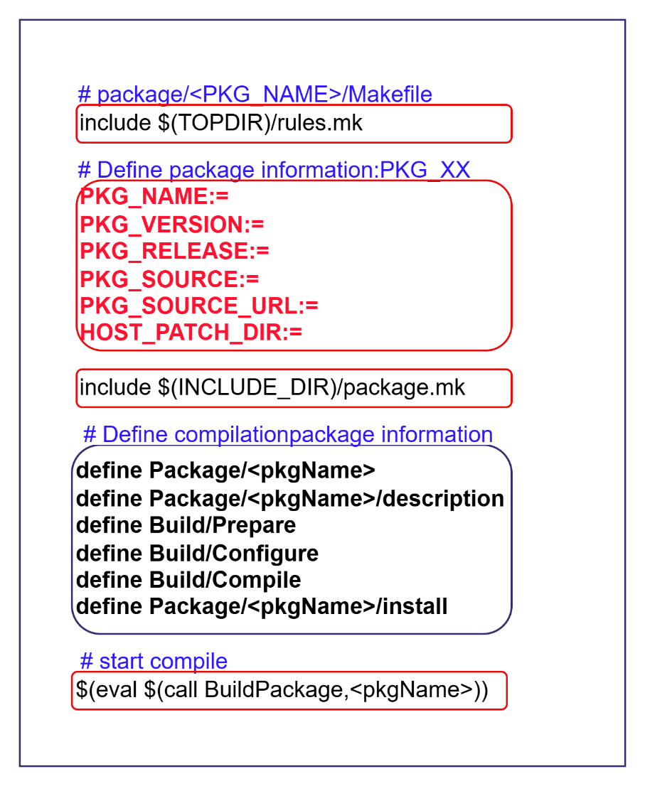
Here is an example. If the module is relatively simple, you only need to refer to the example and modify a few keywords (from omada_gateway/package/tplink/ubus_demo and slightly simplified.)
include $(TOPDIR)/rules.mk
include $(INCLUDE_DIR)/package.mk

PKG_NAME:=ubus_demo
PKG_RELEASE:=1
PKG_VERSION:=1.0
# the source code path
PKG_SOURCE_DIR:=$(TPLINK_DIR)/package/usr_package/$(PKG_NAME)/src
# the path which need to copy to filesystems(including configuration/scripts..)
PKG_FILES_DIR:=$(TPLINK_DIR)/package/usr_package/$(PKG_NAME)/files

#########################################
# CATEGORY: menuconfig root directory
# SUBMENU: sub menu in menuconfig
# TITLE: tile of module
# DEPENDS: depends modules
define Package/$(PKG_NAME)
SECTION:=TP-LINK
CATEGORY:=$(TPLINK_CATEGORY)
SUBMENU:=Apps
MAINTAINER:=TP-LINK
DEPENDS:= +libubus +ubus +ubusd +libpthread
TITLE:=Ubus Demo
endef

define Package/$(PKG_NAME)/Description
This is a demo for ubus
endef

# copy source code to the compilation directory：omada_gateway/build_dir
define Build/Prepare
mkdir -p $(PKG_BUILD_DIR)
$(CP) $(PKG_SOURCE_DIR)/* $(PKG_BUILD_DIR)/
endef

# define openwrt compile command(make package/XXX/compile V=s)
# this part can be empty, mean to use the default rule
# define Build/Compile
# ......
# endef

# define openwrt install command(make package/XXX/install V=s),install the compiled file or other files to the filesystems
define Package/$(PKG_NAME)/install
$(INSTALL_DIR) $(1)/etc/init.d
$(INSTALL_BIN) $(PKG_FILES_DIR)/etc/init.d/ubus-demo.init $(1)/etc/init.d/ubus-demo
$(INSTALL_DIR) $(1)/usr/sbin
$(INSTALL_BIN) $(PKG_BUILD_DIR)/ubus-demo $(1)/usr/sbin
endef

$(eval $(call BuildPackage,$(PKG_NAME)))

Add new products
This section will discuss how to add a new product into our platform, including how to modify compile scripts/makefiles and config files, build up uboot binary files, etc.

Firmware compilation adaptation
Firmware compilation is the most important part, which includes adding new compilation commands, firmware packaging, adaptation and modification of new model catalogs, etc.
- modify compile scripts
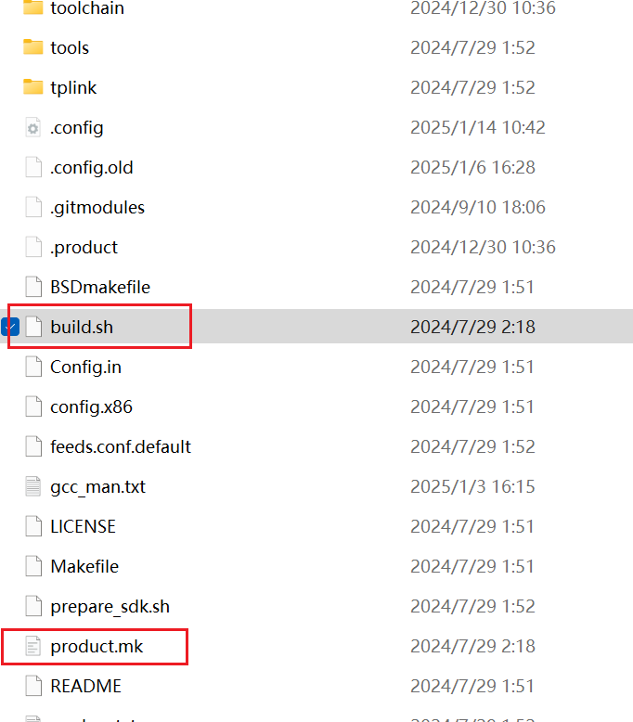
build.sh: Add compilation commands, including the selection of linux and gcc versions during compilation. Generally, just add a new model name after the reference model.
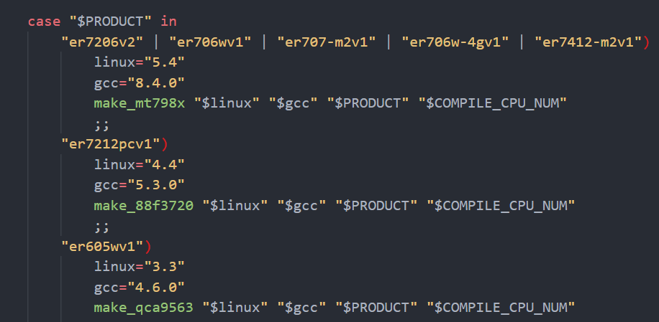
product.mk: pre-compilation operations (config configuration) and post-compilation packaging operations (some models have them). Generally, you can copy the reference model and then modify it accordingly.
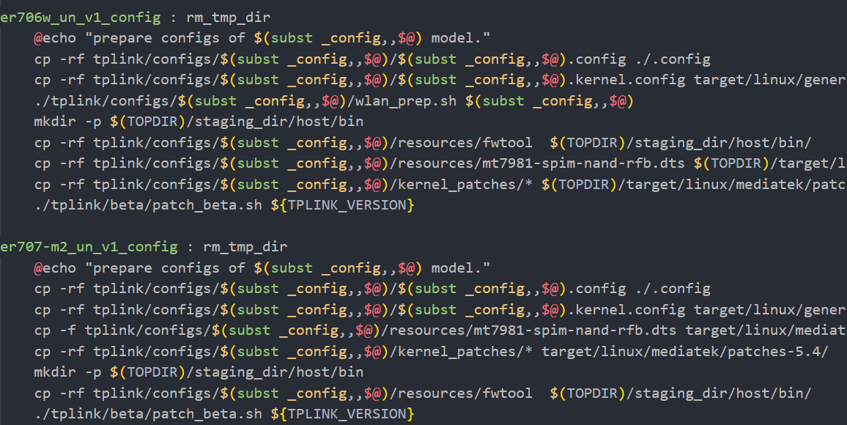
- product directory adaption
The adaptation of the product directory is the most complex and the most important. Generally, it is necessary to adapt and modify the product and hardware information of the new model. If there is no special requirement for the function configuration information, it can be kept the same as the reference model.
The product directory is located in omada_gateway/tplink/configs, each product has a unique directory:
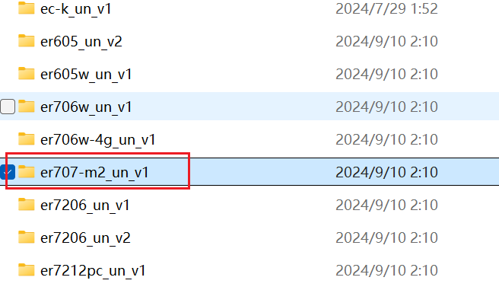
The main files adapted by the model directory include filesystems directory, resources directory, compile config files, etc.
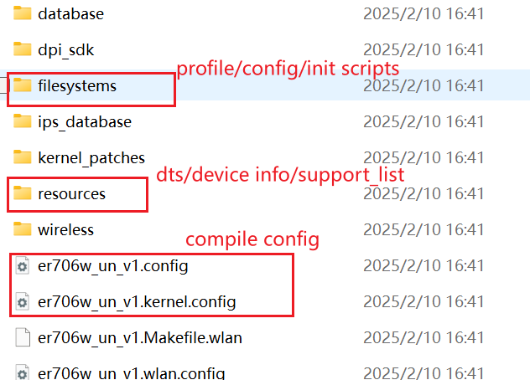
①filesystems directory
Mainly includes the profile/config configuration files used when the prototype is started, and the startup scripts related to the model. After the configuration file is adapted and modified, it is best to compare and confirm with the reference model directory to check where it has not been modified and whether the difference is in line with expectations. (Take the current common board solution ER706W-4G 1.0 as an example. The model name, version, and region are different, and there are 6 common board models in total)
config file: including common board models, common configuration, and difference configuration.
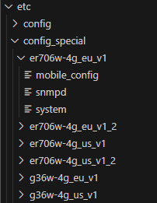
The common configuration files are placed in the config path, and the different parts are placed in config_special/common model directory/path. The file name placed in config_special can be the same as that in config, and only the different configurations are stored. During the startup process, the prototype will parse config+config_special according to the model name to generate the final config configuration file.
Profile configuration file: including common board models and different configurations.
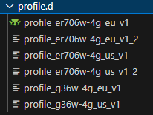
The profile configuration file is placed in the profile.d path. There are only profile files for each common board model (updated after the common board plan is changed later). The naming rule is profile_common board model name. The prototype will generate the final profile configuration file according to the model name during the startup process.
②resources directory
Mainly includes uboot image file, model device tree dts file, packaging/partitioning model.json file, device hardware product information device_info.json file, firmware upgrade isolation support-list.json file, partitiontable.bin used for production testing, etc.
device_info.json (important): Contains basic information about device hardware and products, written during burning, and generally not updated during firmware upgrades.
Each item needs to be carefully confirmed and filled in, and needs to be reviewed when uploaded to the library.
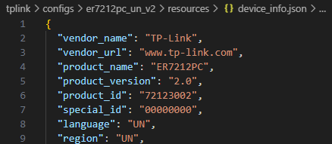
support-list.json: Verify and isolate the device and version during the upgrade, so that the firmware can only be upgraded for specific devices and versions. Mainly matches the four fields in device-info one by one, and supports firmware upgrade if all fields match.

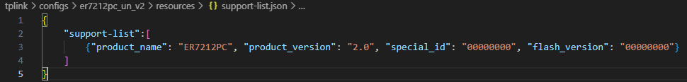
model.json: File used for device partition table and firmware partition packaging. Generally, if there is no special modification to the partition, it does not need to be modified. The packaged firmware name needs to be adapted and modified. Generally divided into debug version and non-debug version, the difference between the two is that the packaged file system image is different.
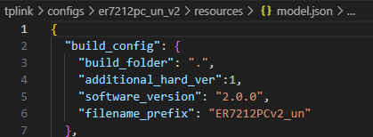
partitiontable.bin: Based on this bin file, the Pro image file used for production testing will be generated. As long as the partition changes, the bin file needs to be modified.
③config compilation configuration file
It is divided into user mode and kernel mode config configuration files.
User mode.config: generally adapts to the model name, (er7212 1.0 is the version selected when the front-end is compiled, and it does not need to be changed if the front-end has not been modified), switch chip model.
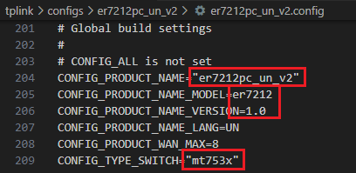
kernel.config: Generally, it does not need to be modified if platform already has another kernel config of same version. Modify it as needed.
- Model hardware and product information adaptation check list
It is easy to miss the adaptation of the hardware and product information of the model. You need to refer to this checklist for adaptation and modification. Not only refer to this checklist, but also pay attention to other information about the model. Update and maintain this checklist in real time.
directory | content | remark
tplink/configs/product_dir/resources/ common_board_model_dir/device_info.json | vendor_name：defaults to "TP-Link"  vendor_url：defaults to "www.tp-link.com"  product_name：product name  product_version：product version  product_id：product id，calculated by rules  special_id：region code  language：country /region  Region：country /region  hw_id：Fill in the hardware ID requested on the DMS website  oem_id：Fill in the oem ID requested on the DMS website  public_key：default  manufacturer_name：defaults to "TP-Link"  manufacturer_full_name：defaults to "TP-Link TECHNOLOGIES"  manufacturer_url：defaults to "www.tp-link.com"  model_name：same as product_name  model_full_name：The full name of the product should be filled in according to the full name on the product project  model_id：same as product_id  model_version：same as product_version  flash_version：defaults to "00000000"  radio：defaults to"0",  multiwan：defaults to "1"  license_key：default | product_id: The command rules are as follows.  The first four digits: model number  If the model number is less than four digits, the high digits are filled with 0, such as 7206, 0706, and 0036. The -M2 suffix is ​​not distinguished for the time being, such as ER707-M2 uses 0707.  Fifth digit: model category  Wired routing and historical models (such as ER7212PC): 0  Wireless routing: 1  LTE routing: 2  Controller routing: 3  Sixth digit: model definition  Ordinary routing: 0  Pro routing: 1  Firewall: 2  Seventh digit: Reserved.  Eighth digit: model version, V1 corresponds to 1, V2 corresponds to 2, and so on.  Supplement ①: Model examples  ER7206v2： 72060002  G36v1： 00360101  G36-4Gv1：00362101  FW8410： 84100201  Supplement ②: If the new model and the historical model have the same product_id, swap the id. For example, ER7212PCv1 has used 72120001, so ER7212v1 is swapped to 72123001. The v2 rule remains unchanged.  hw_id：The hw_id of the new machine needs to be applied for on the DMS website, and the hw_id of the new model will be generated after approval.  oem_id：The OEM ID of the new model needs to be applied for on the DMS website, and the OEM ID of the new model will be generated after approval.
tplink/configs/product_dir/resources/common_board_model_dir /module.json | "build_config": {  "build_folder": default is ".",  "additional_hard_ver": default is 1,  "software_version": fill the firmware version,  "firmware_format": fill the firmware information  },
tplink/configs/ product_dir /resources/support-list.json | "support-list":[  {"model_name": same as device_info.json, "model_version": same as device_info.json, "special_id": same as device_info.json, "flash_version": same as device_info.json},  ] | （same as device_info.json）
tplink/configs/product_dir/filesystems/usr/sbin/tddp_region_cfg | config item 'product_name_Region'  option oem_id 'oem_id'  option special_id 'special_id' | （same as device_info.json）
tplink/configs/ product_dir /filesystems/etc/config/snmpd | config system system  option sysName 'product_name'  option sysDescr 'model_full_name' | （same as device_info.json）
tplink/configs/product_dir/filesystems/etc/profile.d/profile | config global  option verified_version '2_0' | （The version number displayed on the page, for example, if it is 2.0 in device_info.json, fill in 2_0）

Uboot compilation and adaptation
Uboot plays the role of power-on startup, kernel boot, and rootfs loading. The code is provided by the supplier, and the code repo of mtk and marvell are on sdk_mtk and sdk_marvell. In terms of compilation, only a few adaptation modifications are needed to compile and generate uboot firmware, and then put it on the omada_gateway for compilation and packaging.
- Code directory introduce
Code directory:
Compile path: The path generated during compilation. Before compilation, the corresponding version of the supplier source code will be copied, patched, and compiled.

Supplier source code: Contains different versions of atf and uboot source code.
tplink: Contains the directory of each model. The model directory only needs to contain the compilation script, compilation deconfig configuration file, dts file, and patch of each model.
build.sh: The total entry for compilation.
Adaptation compilation script: Select the corresponding version of uboot and atf.
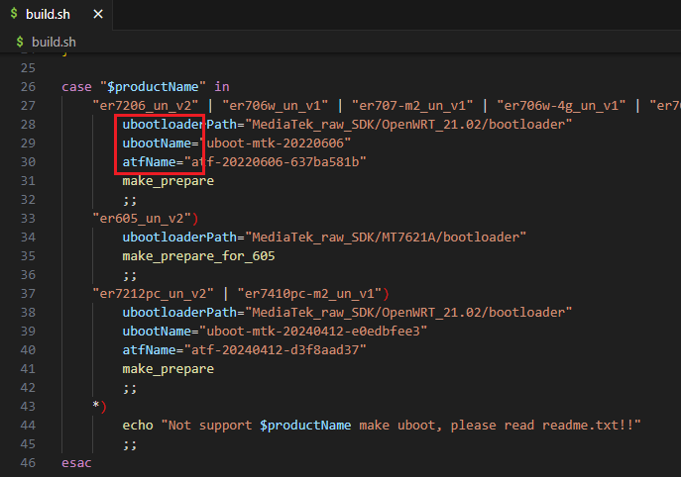
Model directory adaptation: Copy the reference model for adaptation modification
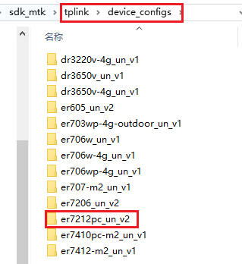
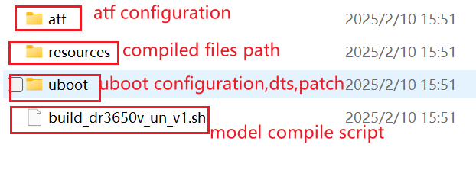
atf configuration file: The configuration file when compiling atf, including cpu chip selection and DDR initialization, generally does not need to be modified.
resources: Compilation product path. After the final compilation is completed, bl2.img and fip.bin will be generated.
uboot: Contains the deconfig configuration file, which will compile the driver and switch. dts device tree file, patch file.
Model compilation script: patch, copy configuration files, compile, and copy the compiled product after the compilation is completed.
Patch file: Since each model is different, mainly reflected in the differences in CPU, switch, and gpio, the functional adaptation of the different parts needs to be distinguished by patching.
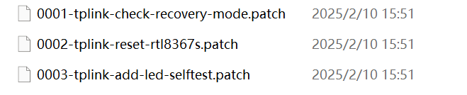
The main functions of the adaptation include panel lights (gpio, switch) lighting self-test, recovery mode, and some other key gpio operations.
Lighting self-test: pull up and down gpio according to the hardware gpio manual to turn on and off the corresponding LED lights.
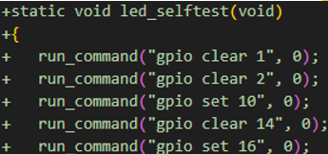
Switch adaptation: adapt switch reset pins, switch network port numbers, etc.
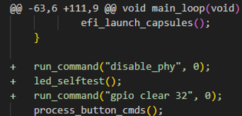
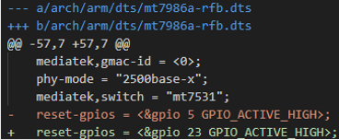
Recovery-mode adaptation: httpd communication + dkmgt firmware code.
- Uboot compilation and update
Steps to compile uboot for different models:
1.Execute ./build.sh model_name in the sdk_mtk directory
2.After the compilation is completed, get the compilation product in \sdk_mtk\tplink\device_configs\model_name\resources
For example, compile the uboot of er7206v2:
1. Execute ./build.sh er7206_un_v2
2. Generate bl2.img and fip.bin in \sdk_mtk\tplink\device_configs\er7206_un_v2\resources
After compiled,you can simply replace the compiled bl2.img and fip.bin located in your target model resource directory ,in this case ,it is omada_gateway/tplink/er7206_un_v2/resources:
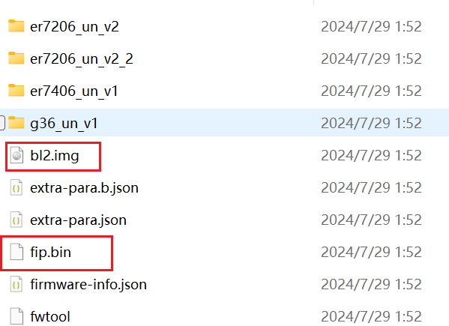

Debug
This part will introduce some common commands to access and do debug on our devices.

Console/SSH log in
Usually we need access to control our device when debugging,here are two ways :Console and SSH.
The Console of devices is usually open if you are using the device for developer, just connect it is enough, the speed of serial please choose 115200.
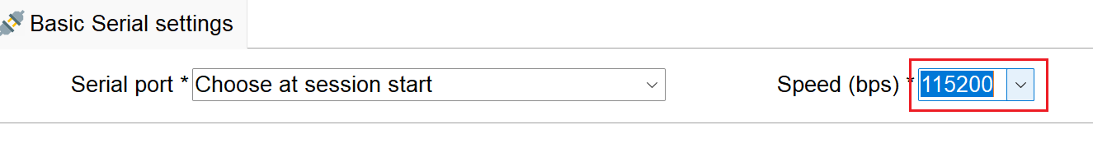
The SSH function needs to enable on the web pages,in System Tools->Diagnostics->Remote Assistance.
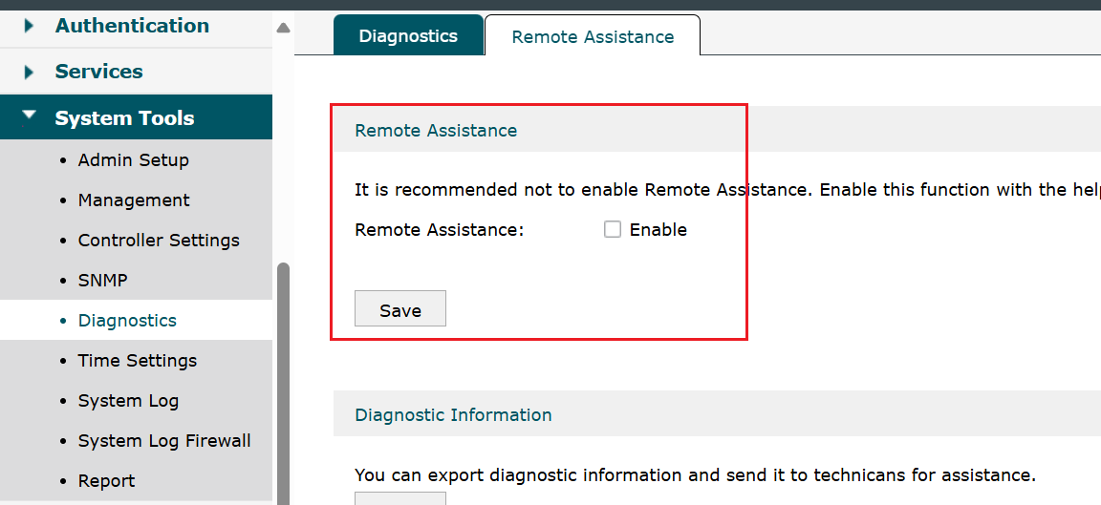
Username:same as device username
Password:same as device password
Enter enable,and then enter debug to come into the debug mode,the password for debug mode usually calculated by following command:
echo -n $(macAddr)admin | md5sum | cut -c -16
or
echo -n $(macAddr)admin$(macAddr)admin | md5sum | cut -c -16
The $(macAddr) means your default lan mac address.
You can use show system-info command to directly get the lan macaddr in cli.
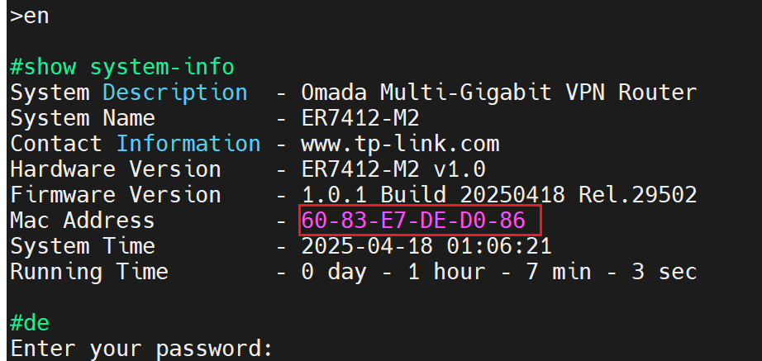
echo -n 60-83-E7-DE-D0-86admin60-83-E7-DE-D0-86admin |sed "s/-/:/g" |md5sum| cut -c -16
Use above command and replace the macaddr to calculate the password.
Some new version products use certificates as debug mode password for safety consideration.
Click the following link to get the real-time password of the devices
串口签名 - 研发签名系统

Enable all ports while using an unsigned device
If you program the entire image file, you will need to write a signature and MAC address for the device later, otherwise only the last LAN will be available on the device. If you cannot write a signature and MAC address for the time being, you can enter the Linux system of the prototype and enter the following command to open all network ports:
echo PASS > /tmp/rsa_check/rsa_result
/etc/init.d/switch restart

